**Documentation of Group 7**

**Operating Instruction**

**Calcium Imaging in Neurons**

Our project is designed for active neuron detection. To make a user-friendly software, we developed a GUI for operation. This documentation will illustrate how to use the software.

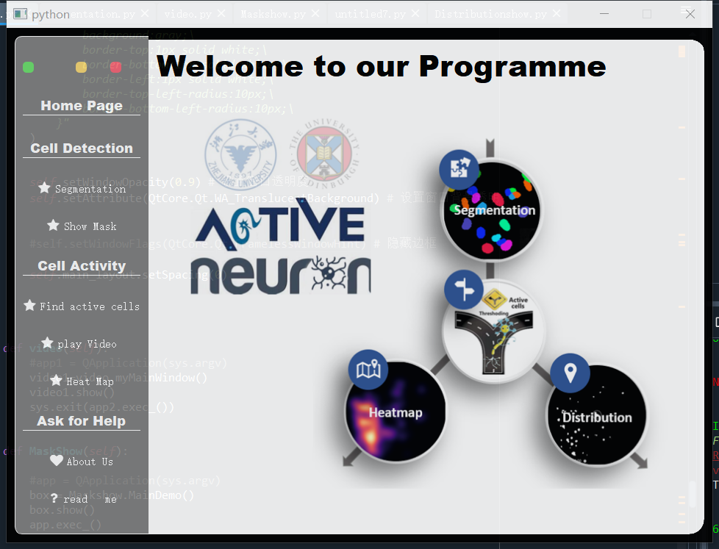

Figure 1. Home page of GUI

First shown here is the home page of our GUI (Fig. 1). The left bar allows you to choose the function of our software. On the top of the bar, there are three buttons, the green one can minimize the GUI, the yellow one can fix the location of the GUI, and the red one can close the GUI and end the software. On the home page, we show our designed logo and the outline of our project. You can see from the window that our project mainly has two functions: cell segmentation and active cell detection. In cell segmentation, you can get the result of the mask from your dataset, and in active cell detection, a video with each frame available can be output to see the cell activity distribution. You can easily get back to the home page by clicking the “Home Page” button, and the “Ask for Help” page presents the information of our group members and a readme file. The directions of each page will be explained with Figures as follows.

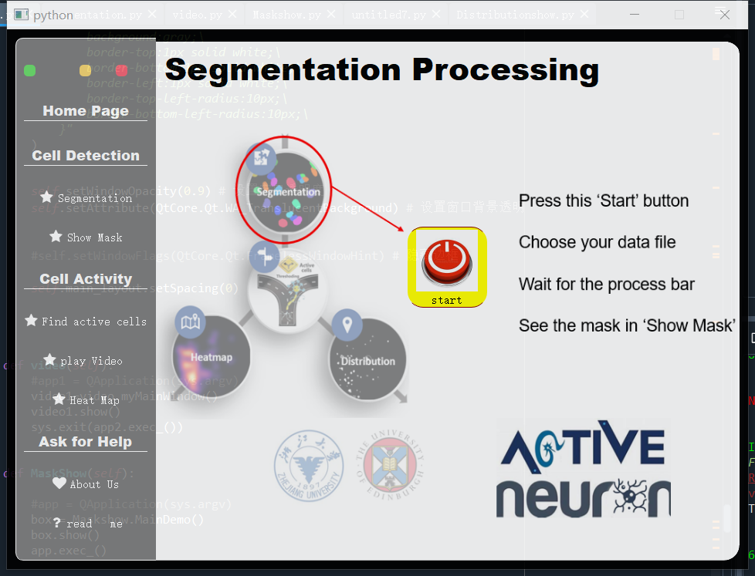

Figure 2. “Segmentation” page

Here is the segmentation function of our project (Fig. 2). We designed a “Start” button to initiate the cell segmentation. When you press the button, our GUI will allow you to choose your dataset from your computer (Fig. 3). After the dataset is loaded, the segmentation program starts to run. You can first choose your preferred threshold by adjusting the slider or the box (Fig. 4). After deciding on the threshold, you can click the “get Mask” button to start segmentation. The process bar (Fig. 5) at the bottom will show the progress of the segmentation and the mask is output when “Mask extracted!” appears (Fig. 6). You can click the "Show Mask" button to see the output of the mask (Fig.7). A JSON file containing the location of each mask labeled cell is also produced and stored in your computer. If the output mask is not satisfactory, you could re-adjust the threshold and get mask again, until the chosen threshold gives you a satisfactory mask.

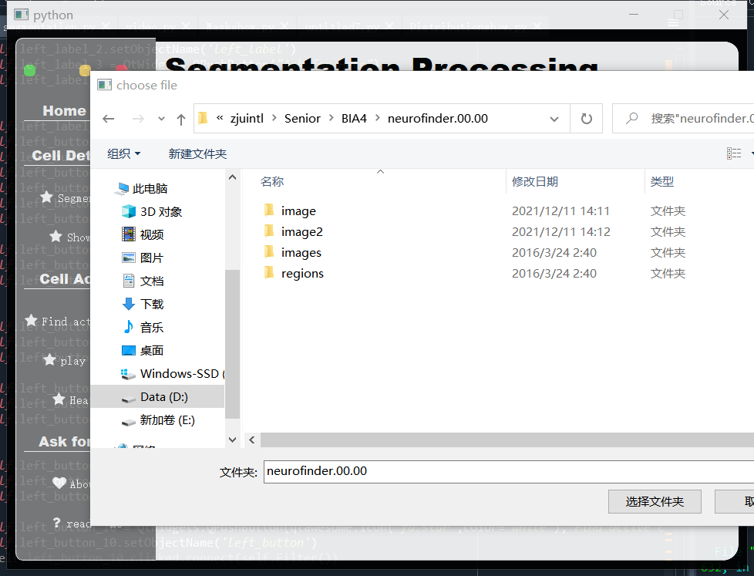

Figure 3. Interface to choose files.

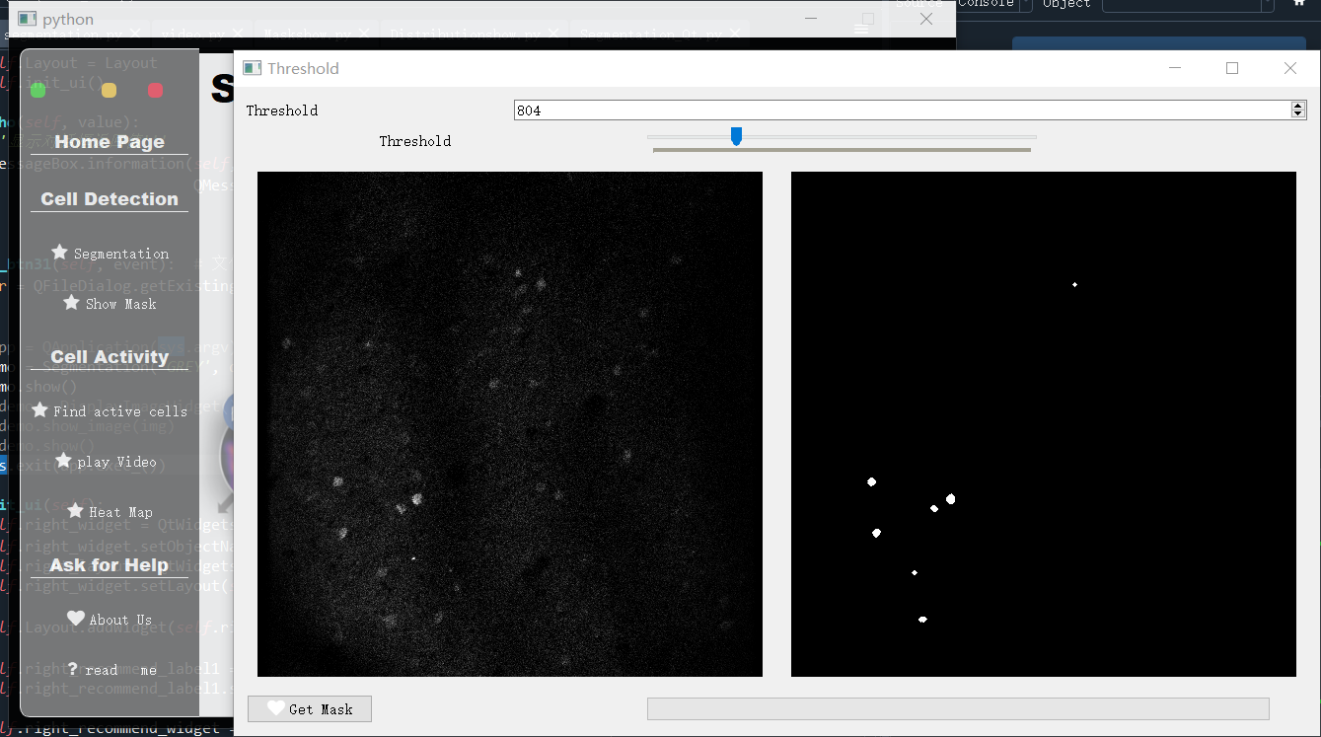

Figure 4. Interface for the user to select the threshold 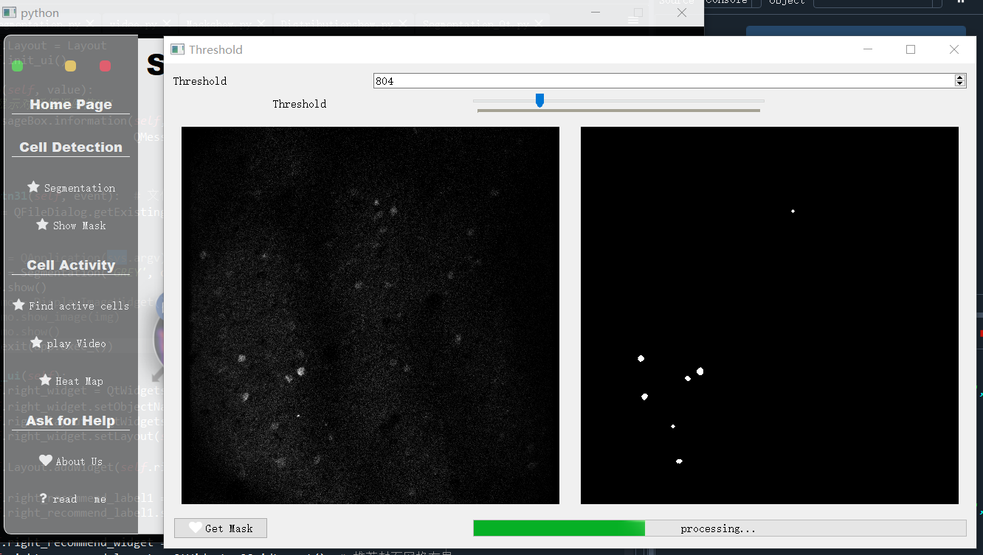

Figure 5. Processing bar

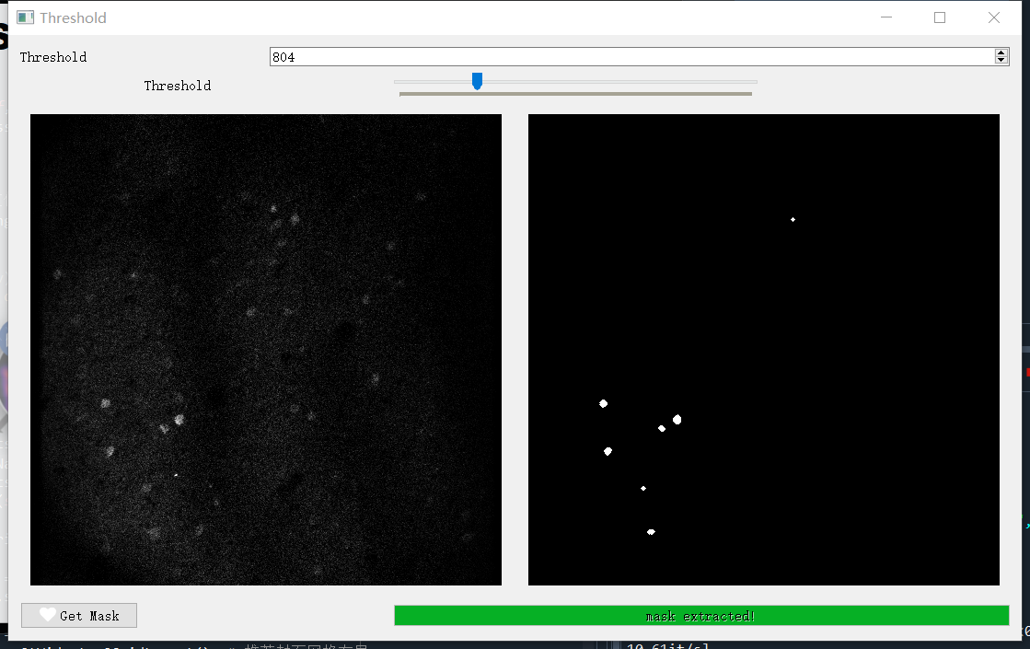

Figure 6. Signs of mission completion

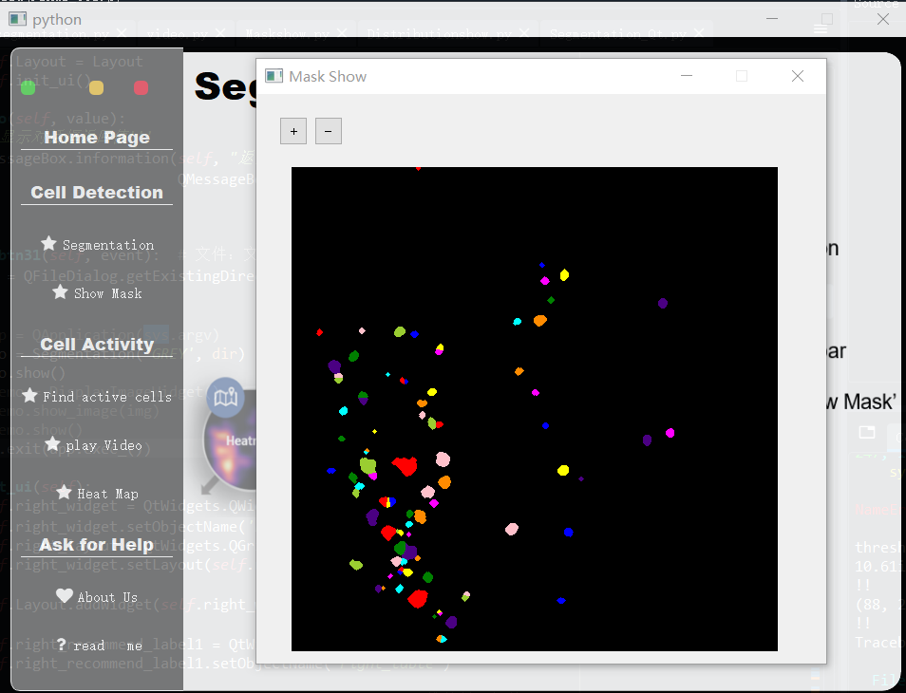

Figure 7. Mask output in a given threshold.

Next, using the JSON file generated in the segmentation step, you can continue with further active cell detection. As the “Find active cell” page shows (Fig. 8), you can press the “Process” button to start cell filtering. A video of cell location in each frame and a heatmap of active cell distribution will be generated. You can choose the video from your results and click “Play video” to see active cell location and the cell number in each frame (Fig. 9). What’s more, you can drag the mouse to choose or stop the video at each frame to see cell distribution. The heatmap of accumulated cell distribution will be shown if you click the “Heat map” button (Fig. 10). Also note that a csv file containing the relative fluorescence change signals of all cells would be automatically generated in this step.

At last, if you get into any trouble using our software, you can click “About us” to obtain the contact information of our group members (Fig 11). The “Readme” page also explains the logic of our project (Fig. 12).

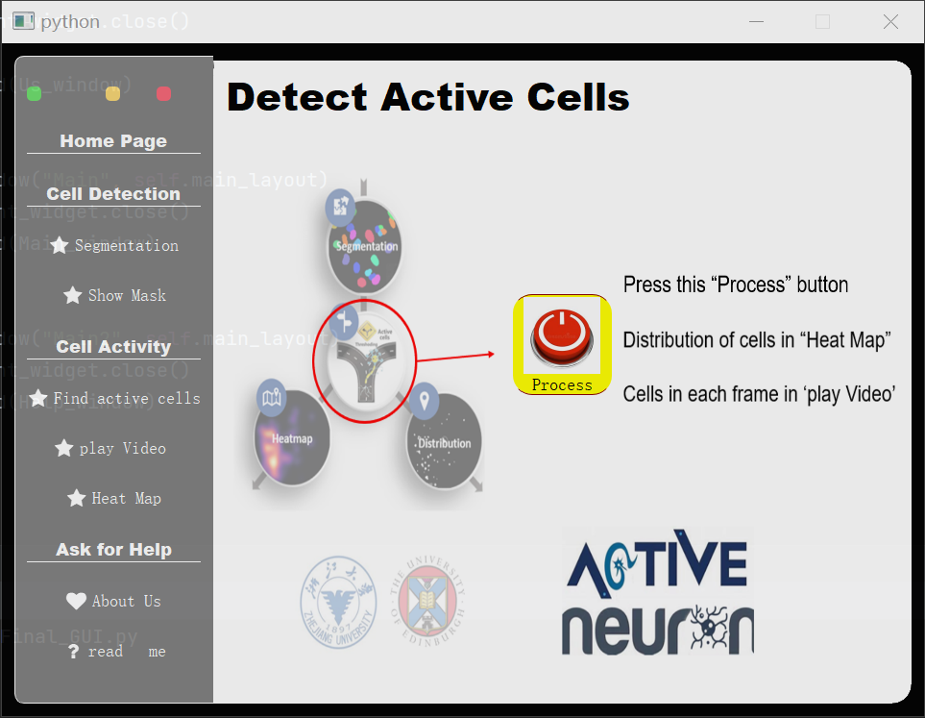

Figure 8. “Find active cell” page

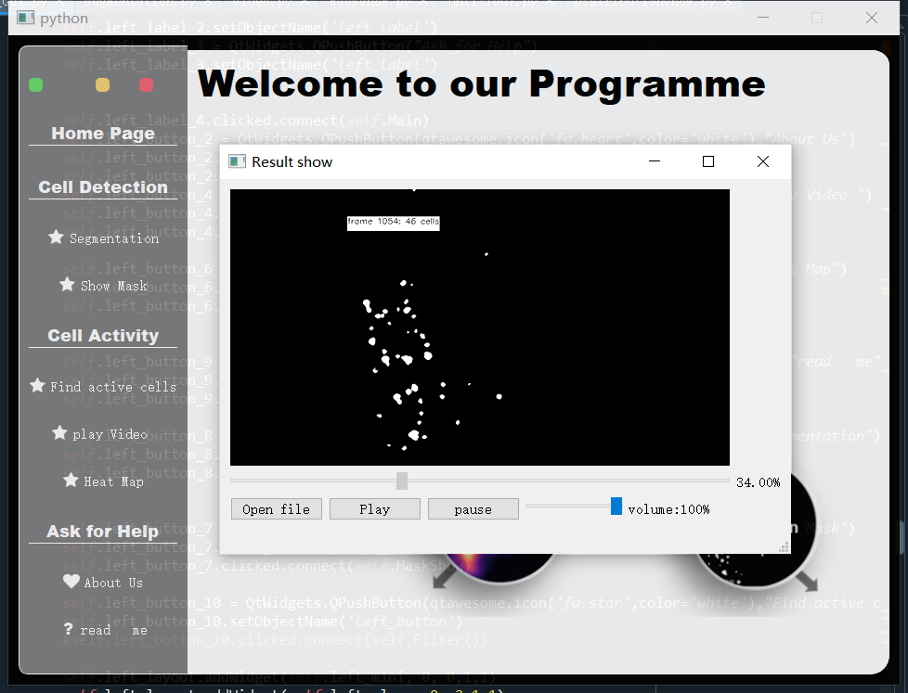Figure 9. A screenshot of cell location in one frame

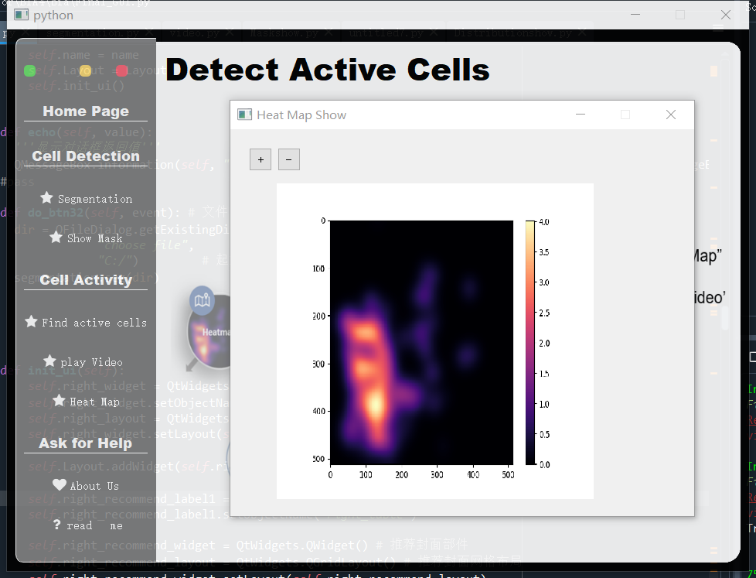

Figure 10. The heatmap of cell distribution.

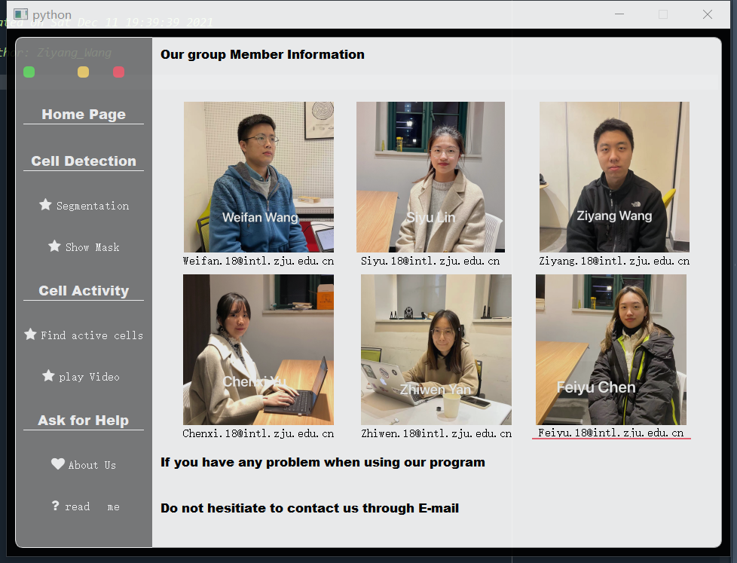

Figure 11. The information of our group members.

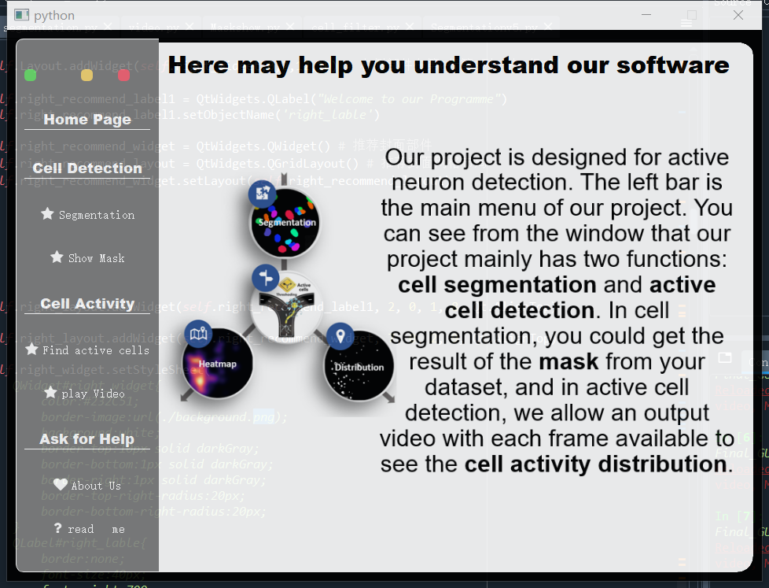

Figure 12. “Readme” page.